1. **Capstone Project Title: COLLEGE ERP**
2. **Group Members:**
3. **Problem statement:**

Nowadays managing the students' details for Institutions has been a very critical task. Doing a lot of paperwork, excels, documentation and then they get misplaced and we can also call as they are not secure.

To help institutions to maintain data securely and to make teachers' lives easy we are developing an application to fetch all the information in one single roof.

1. **Objectives:**

Our main objective is to create a single platform for all Institutions to maintain a student database.

1. **Capstone Project Description:**

The participants of our system are mentioned below along with their functionalities

**ADMIN**

Creating, monitoring, updating, performance and analyzing the performance. Admin is a person of the highest level who can monitor the academic performance/activities of the staff and students in the Institution. Authorized person to create, update or retrieve the data of top level (HOD) to the bottom level (Student).

**CO-ADMIN**

Co-admin can be head of the department or staff of the department. One co-admin can be assigned for each department. Co-admin has a limited function of Admin and is restricted to his department.

**STAFF**

Staff uploads and monitors data such as attendance, internals and externals marks of the subjects which are allocated by the Admin. Staff can also Share the notes, Assignments and unit tests.

**STUDENT**

Students can retrieve academic data such as Attendance and internal or marks along with notes, Assignments and unit tests. Student can also complete the assignment and submit it through our app.

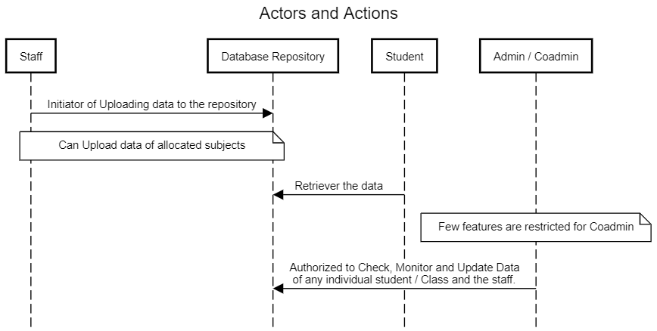

1. **Capstone Project Deliverables (Final Output):**

Full-fledged android application to maintain academic details of the subjects, staff and students.

Tools to be used to develop the application are

* Front end:
  + - React Native
    - Chakra UI
    - JavaScript
    - Redux
* Back end
  + Node.js
* Database
  + Supabase - Cloud backend

1. **Key milestones:**

Key Milestones are described in the

|  |  |
| --- | --- |
| **Milestone No** | **TOPIC** |
| 1 | Preparing Epics, User Stories and sub tasks |
| 2 | Wireframing the UI & Designing UML diagrams |
| 3 | Developing the Project |
| 5 | Writing the test cases |
| 6 | Testing the Developed Project |
| 7 | Preparing Project Presentation |
| 8 | Preparing the Final Project Report |

1. **Constraints:**

Few difficulties might be faced by the Admin and Co-admins while creating the Departments, allocating subjects, allocating IA Tests. Security for the database must be considered as high priority.

1. **Estimated Capstone Project Duration:**

Estimated to complete in four months.

1. **Estimated Capstone Project Cost:**

* Open-source tools can be used to develop the Project, but we must have a laptop or Desktop with high configuration. The least System Requirements are:
  + **Operating System:** Windows 10 +
  + **System Bus Capacity:** 64 Bit
  + **RAM:** 8 GB
  + **Processor:** Pentium 5 or any other equitant one
* Infrastructure cost depends on the Office setup.